The Astronomy Project

Mrs. Lindsey was everyone’s favorite teacher at Lincoln Elementary School. She was known for her entertaining teaching techniques. One day she walked into the classroom and announced to the class that they would all be seeing stars in their futures. She then asked, “Does anyone know what astronomy is?”

Olivia raised her hand and said, “I’m a Libra.”

Mrs. Lindsey responded, “I can understand why you would think that astrological signs are part of astronomy because astrology and astronomy both deal with celestial beings. In fact, many of the constellations in the sky have given their names to astrological signs”

Mrs. Lindsey then went on to explain that astrology is the belief that the location and movement of stars and planets affect the way events transpire on earth, which is why horoscopes are based on astrological signs. Astronomy, however, is a branch of science that deals with celestial bodies, the universe as a whole and space. “ We are going to be learning about astronomy in this unit, and that is why you will be seeing stars in your future.”

“I love looking at the stars at night,” said Olivia.

When Mrs. Lindsey asked who else liked looking at stars, everyone in the class raised their hands. She then passed out star charts and asked the class to look at the sky that night and record the visible constellations.

The next day in class, everyone was super excited to share their observations.

“I saw Ursa Minor,” announced Andrew enthusiastically. “So did I.” said Olivia, “It looks like a dot - to- dot ladle.”

“That’s great,” responded Mrs. Lindsey, “and did you know that Ursa Minor is also called the Little Dipper because it looks like a ladle?”

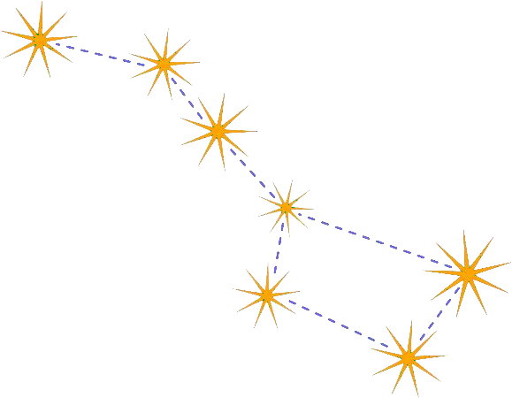

“Isn’t there a Big Dipper too?” asked Tim.

“Yes, there is, and it is called Ursa Major,” said Mrs. Lindsey.

Mrs. Lindsey then asked the class if they would like to become part of the galaxy. They all agreed that that sounded like a fun idea, but they wondered how it would work. Mrs. Lindsey explained that she would assign each student a constellation, and that they would each make a poster board illustration of their constellation over the weekend. “From there on,” she said, “it will be a surprise.” She passed out one poster board and one glow- in- the- dark marker to each student and wished them all a good weekend.

When the students got to class Monday morning, they were brimming with enthusiasm. Mrs. Lindsey used a poster board to demonstrate to the students how she wanted them to punch two holes at the top of their poster boards and then weave a piece of string through the holes to form a necklace so that they could hang their constellations around their necks and wear them.

After the students had completed constructing their wearable constellations, they donned them and waited to see what would happen next.

Mrs. Lindsey arranged the students around each other in a similar fashion to the way the constellations appeared on the constellation chart. Next, she closed the blinds and turned off the lights. She asked them to circle around the class room while making individual motions as they went. They had now become the constellations dancing in the nighttime sky.

“ Awesome! We can all see each other glowing and moving around just like the stars do,” the students said in unison.

All of the students agreed that it was their favorite lesson so far that year. They especially liked the fact that Mrs. Lindsey had recorded their version of the constellations so they could watch it over again and show it to their parents.

